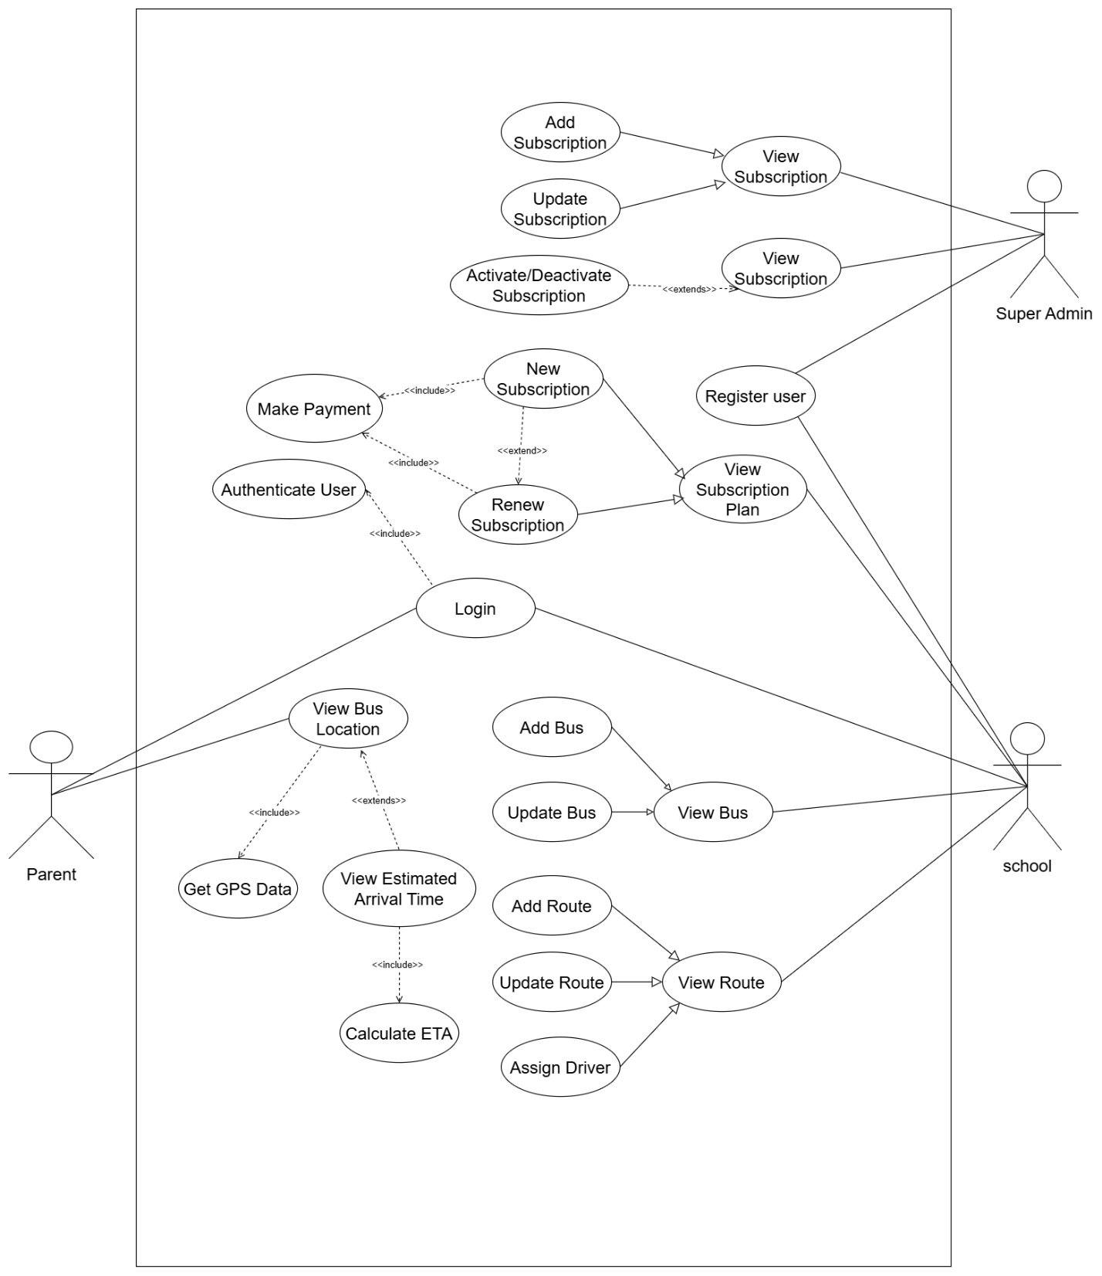
high level use case description
Use Case: Register
Actors: Super Admin, School
Description: Super Admin adds school in the system when school buys subscription. Super admin provides the school information such as name, address, contact details and subscription plan. School receives logins to the system. Their parents and students can then be added to the system by school.
Use Case: Login
Actors: Parent, School, Super Admin.
Description: The system lets users fill in their credentials to gain access to the system. System checks usernames and passwords with stored data. Authentication is invalidated on a mismatch of credentials.
Use Case: Authenticate User
Actors: Parent, School, Super Admin
Description This occurs following a login attempt. System authenticates the identity of the user and verifies the user role within the system. Depending on role, user will be redirected to the right dashboard.
Use Case: View Bus Location
Actors: Parent
Description: Real time map on current location of school bus can be viewed by parents. Bus provides GPS co-ordinates to the system which it displays. This feature requires the parents to login before they can access it.
Use Case: Get GPS Data
Actors: Parent
Description: System constantly retrieves position of the bus using GPS coordinates tracker installed on the bus when parent requests the position of the bus. This information is updated after every few seconds to keep location up to date.
Use Case: View Estimated Arrival Time
Actors: Parent
Description: Parents will be able to see the time of bus arrival to their stop. System calculates ETA on the basis of the position of the bus and the route. The time is continually changing with bus movements.
Use Case: Calculate ETA
Actors: Parent
Description: In parent requests ETA, GPS data, traffic conditions, and distance left will be used to calculate a hinted time of arrival. It takes into consideration the bus path and all those stops that lie in between the present position and the destination stop.
Use Case: Add Bus
Actors: School
Description: To insert new buses into the system, school administration is forced to fill the bus information such as registration number, capacity, and model. Every bus is assigned individual system ID.
Use Case: Update Bus
Actors: School
Description: School is able to update the information about buses whenever necessary. They are able to modify bus information such as bus capacity and registration number. System stores the new information.
Use Case: View Bus
Actors: School
Description: School administrator may be provided with the list of buses that are registered in the system. They are able to access more detailed information about each particular bus such as its present status as well as its allocated routes.
Use Case: Add Route
Actors: School
Description School develops new bus routes by determining sequence of stops. Each of the stops entails name of the location, GPS position and the time when the location will be picked. Route is given a special name.
Use Case: Update Route
Actors: School
Description: School is able to edit existing routes when stops are modified or when times require a change. They are able to add new stops, delete old ones or rearrange the sequence of the stops in route.
Use Case: View Route
Actors: School
Description: School can view all routes in system. They are able to access the full route information such as the stops, timing and the bus that is assigned to that route.
Use Case: Assign Driver
Actors: School
Description School designates a driver to a route. System requires such details about drivers as name, license number and contact details. A single driver may be placed on two or more routes but not simultaneously.
Use Case: New Subscription
Actors: School
Description: School buys subscription plan to receive access to the system. They call super admin or buy online, choose a type of plan depending on the number of buses or students. The school has to be added by a super admin and has to be paid before that.
Use Case: Renew Subscription
Actors: School
Description: School can renew subscription when this is expired. System displays outstanding plan details and expiry date. School chooses renewal date and makes payment.
Use Case: Make Payment
Actors: School
Description: School is a subscriber and the payment can be made using available payment means. System takes the payment safely and produces receipt. Super admin is informed of payment to be able to add school to system.
Use Case: view Subscription Plan.
Actors: School
Description: School is able to verify available subscription plans in terms of their features and prices. This will assist them in making the correct choice of plan depending on their needs when they make a purchase.
Use Case: Add Subscription
Actors: Super Admin
Description: Super admin buys subscription after school and sets up his or her account in system and gives subscription plan. They provide their school information, time of subscription and swing the account on. School is now able to log in and begin adding buses, routes and parents.
Use Case: Update subscription
Actors: Super Admin
Description: Super admin has the ability of changing the subscription details of school. They are able to alter type of the plan, increase one of its terms or reset one such as maximum buses. This is done when the school is in upgrades or requires changes in the plans.
Use Case: View Subscription
Actors: Super Admin, School
Description: Schools will be able to view their existing subscription plan, name of the plan, date, and expiry date. All schools subscriptions can be viewed by the super admin and thus can be manipulated.
Use Case: Activate/Deactivate Subscription
Actors: Super Admin
Description: The super admin is able to activate or deactivate the subscription of any school manually. This comes in handy in case of payment problems, subscription runs out or testing. Inactivated schools are not allowed to access system features and so are the parents.

Extended Use Case Descriptions
1. Use Case: View Bus Location
Actors: Parent
Description: The parent can view the real time position of the school bus of their child on a map. Systems retrieve GPS information with the bus tracking device and displays the current position with route information to parent to know the position of the bus at any given time.
Actor Action | System Action
 | 1. The system displays the parent dashboard in which there is track bus option.
2. Parent selects "Track Bus" option.
 | 3. The system retrieves assigned bus details of student who belong to respective parents.
 | 4. System receives current GPS coordinates from bus.
 | 5. The system displays bus location on interactive map.
6. Parent views current bus position and other stops registred.
 | 7. System continuously updates location every 10-20 seconds automatically.
 | 8. System displays bus icon moving on map as new GPS data arrives.
9. Parent can zoom in/out the map to get better view.
 | 10. System shows last updated timestamp for location data.
Alternatives course of events:
Step 4: If GPS device is offline or not sending data, system displays last known location with timestamp and shows "Error Tracking the bus! Network error" message.
Step 5: If parent don’t have student assigned to any bus route, system shows error message "No bus assigned to your child. Please contact school."

2. Use Case: New Subscription
Actors: School, Super Admin
Description:
School buys subscription plan to use the bus tracking plan. School picks right plan, pays, and super admin unlocks their account in system to allow school to use the features.

Actor Action | System Action
 | 1. The system shows subscription plans that are available with features and pricing.
2. The school reviews all the available subscription plans like Basic, Standard, and Premium.
 | 3. The system shows features like number of buses allowed, students limit, and other features.
4. School chooses the subscription plan.
 | 5. System displays the plan details and total amount of the chosen plan.
6. School confirms plan selection and proceeds to make payment.
 | 7. System redirects school to payment gateway.
8. School makes payment
 | 9. System verifies payment status from gateway.
 | 10. System generates payment receipt and invoice.
 | 11. System sends payment confirmation email to school with receipt.
 | 12. System notifies super admin about new subscription purchase.
13. Super admin reviews school details and payment confirmation.
14. Super admin creates school account in system.
 | 15. System sends welcome email to school with login credentials and setup instructions.

Alternatives course of events:
Step 9: When payment is declined or not successful, the system displays an error message and will ask the school to make another attempt at payment or select an alternative payment method.
Step 9: When payment gateway failure or not responsive then system displays technical error and requests school to resume later.
Step 13: In case the school information is not complete or valid, super admin demands more information of school prior to account creation.

